Removing loops
Introduction:
To introduce the subject we ned to talk about the Album project. The project album in of these functions trace a user. This user is identified for the moment by an IP address. From this IP address there is a service that get from it gps coordinates or the address with the street... Now here is our subject: to know what's the weather like we can give an address or gps coordinates. In this paper we will use gps coordinates. There is a distant service that can return in a value with perl the weather forecast. The heck is that this weather forecast tructure is very complex.

The structure:
The structure is composed of a list. In this list there are other lists. To read them, the basic algorithm would be: a loop in a loop and so on and so fourth. This paper will try to remove loops of loops.

The algorithm:
Let's say we have a list or array where the weather forecast is stored. We read this list that contains information in each node(element of the list). In each node of the list, we check if the information in it is a hash or value. If it is a string we print it on the screen otherwise we save the context and then go to the the node. When the list is over we return to the context saved previously and then follow the list of the list till the list is over. To save the context we use push, and to go back to to the context we use pop.

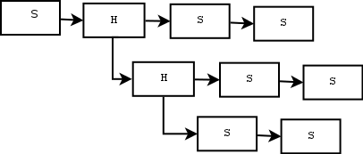

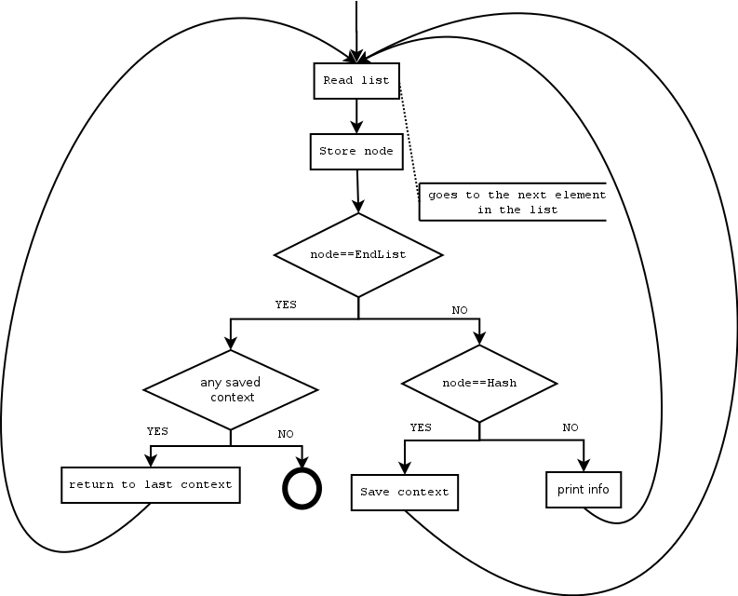
The algorithm is not implemented yet. The graphic above is just a sketch of it.
Next is a work to prepare the above work...

The following is not final work
To get a dump of the structure a perl script was necessary:

#!/usr/bin/perl

use LWP::Simple;
# will do weather forecast
# use module
use XML::Simple;
use Data::Dumper;
use io::MySec;
use io::MyNav;
print "Content-Type: text/html\n\n"; # create object
$xml = new XML::Simple;
my ($L,$l)=(38.8225909761771,-2.4609375);
#getsGPSCoordinates();
my $wfc=get("http://api.wunderground.com/auto/wui/geo/WXCurrentObXML/index.xml?query=$L,$l");

open(W,">wfc_data.$$.xml") or die("error $!");
print W $wfc;
close(W) or die("error $!");

# read XML file
$data = $xml->XMLin("wfc_data.$$.xml");
print "--->$data->{heat_index_f}";
foreach(keys %{$data}){
my $r= (&is_hash($data->{$_})) ? " is an hash" : ((&is_array($data->{$_})) ? " is an array" : "is a string");
print "----ooo)$_:$data->{$_} $r"; }
#print "Content-type: text/html\n\n";
# print output print "";
print Dumper($data);
print " ";
unlink("wfc_data.$$.xml");
sub is_array{ my ($re)=@_; return ref($re) eq 'ARRAY'; }
sub is_hash{ my ($re)=@_; return ref($re) eq 'HASH'; }

This is how the structure is:
http://dorey.heliohost.org//cgi-bin/weat...

--->NA
----ooo)heat_index_f:NA is a string
----ooo)pressure_in:30.30 is a string
----ooo)termsofservice:HASH(0xd923508) is an hash
----ooo)credit_URL:http://wunderground.com/ is a string
----ooo)icons:HASH(0xd926f58) is an hash
----ooo)wind_gust_mph:HASH(0xd926628) is an hash
----ooo)local_epoch:1324300489 is a string
----ooo)wind_degrees:310 is a string
----ooo)visibility_km:N/A is a string
----ooo)observation_time_rfc822:Mon, 19 Dec 2011 13:00:00 GMT is a string
----ooo)history_url:http://www.wunderground.com/history/airport/LEAB/2011/12/19
/DailyHistory.html is a string
----ooo)observation_epoch:1324299600 is a string
----ooo)windchill_f:39 is a string
----ooo)pressure_string:30.30 in (1026 mb) is a string
----ooo)heat_index_c:NA is a string
----ooo)wind_string:From the NW at 10 MPH is a string
----ooo)local_time_rfc822:Mon, 19 Dec 2011 13:14:49 GMT is a string
----ooo)wind_dir:NW is a string
----ooo)icon:clear is a string
----ooo)visibility_mi:N/A is a string
----ooo)relative_humidity:53% is a string
----ooo)observation_time:Last Updated on December 19, 2:00 PM CET is a string
----ooo)heat_index_string:NA is a string
----ooo)station_id:LEAB is a string
----ooo)temperature_string:45 F (7 C) is a string
----ooo)dewpoint_string:28 F (-2 C) is a string
----ooo)local_time:December 19, 2:14 PM CET is a string
----ooo)weather:Clear is a string
----ooo)ob_url:http://www.wunderground.com/cgi-bin/findweather
/getForecast?query=38.95000076,-1.85000002 is a string
----ooo)forecast_url:http://www.wunderground.com/global/stations/08280.html is a string
----ooo)windchill_c:4 is a string
----ooo)display_location:HASH(0xd9237c8) is an hash
----ooo)temp_f:45 is a string
----ooo)wind_mph:10 is a string
----ooo)icon_url_base:http://icons-ak.wxug.com/graphics/conds/ is a string
----ooo)windchill_string:39 F (4 C) is a string
----ooo)credit:Weather Underground NOAA Weather Station is a string
----ooo)dewpoint_f:28 is a string
----ooo)image:HASH(0xd923468) is an hash
----ooo)pressure_mb:1026 is a string
----ooo)dewpoint_c:-2 is a string
----ooo)temp_c:7 is a string
----ooo)observation_location:HASH(0xd5dce98) is an hash
----ooo)icon_url_name:.GIF is a string
$VAR1 = {

'heat_index_f' => 'NA',
'pressure_in' => '30.30',
'termsofservice' => {
'link' => 'http://www.wunderground.com/weather/api/d/terms.html',
'content' => 'This feed will be deprecated. Please switch to http://www.wunderground.com/weather/a
},
'credit_URL' => 'http://wunderground.com/',
'icons' => {
'icon_set' => {
'Helen' => {
'icon_url' => 'http://icons-ak.wxug.com/i/c/i/clear.gif'
},
'Default' => {
'icon_url' => 'http://icons-ak.wxug.com/i/c/a/clear.gif'
},
'Simple' => {
'icon_url' => 'http://icons-ak.wxug.com/i/c/g/clear.gif'
},
'Old School' => {
'icon_url' => 'http://icons-ak.wxug.com/i/c/d/clear.gif'
},
'Mobile' => {
'icon_url' => 'http://icons-ak.wxug.com/i/c/f/clear.gif'
},
'Generic' => {
'icon_url' => 'http://icons-ak.wxug.com/i/c/c/clear.gif'
},

1 of 2

12/19/11 2:19 PM

http://dorey.heliohost.org//cgi-bin/weat...
'Smiley' => {
'icon_url' => 'http://icons-ak.wxug.com/i/c/b/clear.gif'
},
'Incredible' => {
'icon_url' => 'http://icons-ak.wxug.com/i/c/k/clear.gif'
},
'Cartoon' => {
'icon_url' => 'http://icons-ak.wxug.com/i/c/e/clear.gif'
},
'Contemporary' => {
'icon_url' => 'http://icons-ak.wxug.com/i/c/h/clear.gif'
}
}
},
'wind_gust_mph' => {},
'local_epoch' => '1324300489',
'wind_degrees' => '310',
'visibility_km' => 'N/A',
'observation_time_rfc822' => 'Mon, 19 Dec 2011 13:00:00 GMT',
'history_url' => 'http://www.wunderground.com/history/airport/LEAB/2011/12/19/DailyHistory.html',
'observation_epoch' => '1324299600',
'windchill_f' => '39',
'pressure_string' => '30.30 in (1026 mb)',
'heat_index_c' => 'NA',
'wind_string' => 'From the NW at 10 MPH ',
'local_time_rfc822' => 'Mon, 19 Dec 2011 13:14:49 GMT',
'wind_dir' => 'NW',
'icon' => 'clear',
'visibility_mi' => 'N/A',
'relative_humidity' => '53%',
'observation_time' => 'Last Updated on December 19, 2:00 PM CET',
'heat_index_string' => 'NA',
'station_id' => 'LEAB',
'temperature_string' => '45 F (7 C)',
'dewpoint_string' => '28 F (-2 C)',
'local_time' => 'December 19, 2:14 PM CET',
'weather' => 'Clear',
'ob_url' => 'http://www.wunderground.com/cgi-bin/findweather/getForecast?query=38.95000076,-1.85000002',
'forecast_url' => 'http://www.wunderground.com/global/stations/08280.html',
'windchill_c' => '4',
'display_location' => {
'country' => 'SP',
'longitude' => '-2.460938',
'elevation' => '1057.00000000 ft',
'state_name' => 'Spain',
'country_iso3166' => 'ES',
'full' => 'El Bonillo, Spain',
'state' => {},
'city' => 'El Bonillo',
'zip' => '00000',
'latitude' => '38.822591'
},
'temp_f' => '45',
'wind_mph' => '10',
'icon_url_base' => 'http://icons-ak.wxug.com/graphics/conds/',
'windchill_string' => '39 F (4 C)',
'credit' => 'Weather Underground NOAA Weather Station',
'dewpoint_f' => '28',
'image' => {
'link' => 'http://wunderground.com/',
'url' => 'http://icons-ak.wxug.com/graphics/wu2/logo_130x80.png',
'title' => 'Weather Underground'
},
'pressure_mb' => '1026',
'dewpoint_c' => '-2',
'temp_c' => '7',
'observation_location' => {
'country' => 'SP',
'longitude' => '-1.85000002',
'elevation' => '2310 ft',
'country_iso3166' => 'ES',
'full' => 'Albacete, ',
'state' => {},
'city' => 'Albacete',
'latitude' => '38.95000076'
},
'icon_url_name' => '.GIF'
};

2 of 2

12/19/11 2:19 PM

